Telecom Customer Churn Analysis Report
This report outlines the process of exploring, building, and evaluating a machine learning model to predict customer churn in a telecom dataset. The objective is to identify customers at risk of leaving the service and provide actionable insights to support customer retention strategies.

Data Identification and Collection
The dataset consists of telecom customer information, capturing various aspects of customer behaviour and service usage. The key components include:
- Customer Demographics: Gender, Senior Citizen status, Partner status, Dependents
- Account Information: Tenure (length of time with the company), Contract type, Payment method, Paperless billing
- Service Usage: Phone service, Internet service, Online security, Tech support, Streaming services
- Billing Information: Monthly charges and Total charges
- Churn Status: Indicates whether the customer has churned (Yes/No)

Exploratory Data Analysis
Exploratory data analysis was conducted to understand customer behaviour and identify patterns associated with churn. The analysis revealed several important insights:
- Customers with shorter tenure are more likely to churn
- Month-to-month contracts show significantly higher churn compared to long-term contracts
- Customers using fiber optic internet services exhibit higher churn rates
- Certain service features, such as fiber optic internet, are associated with higher churn rates

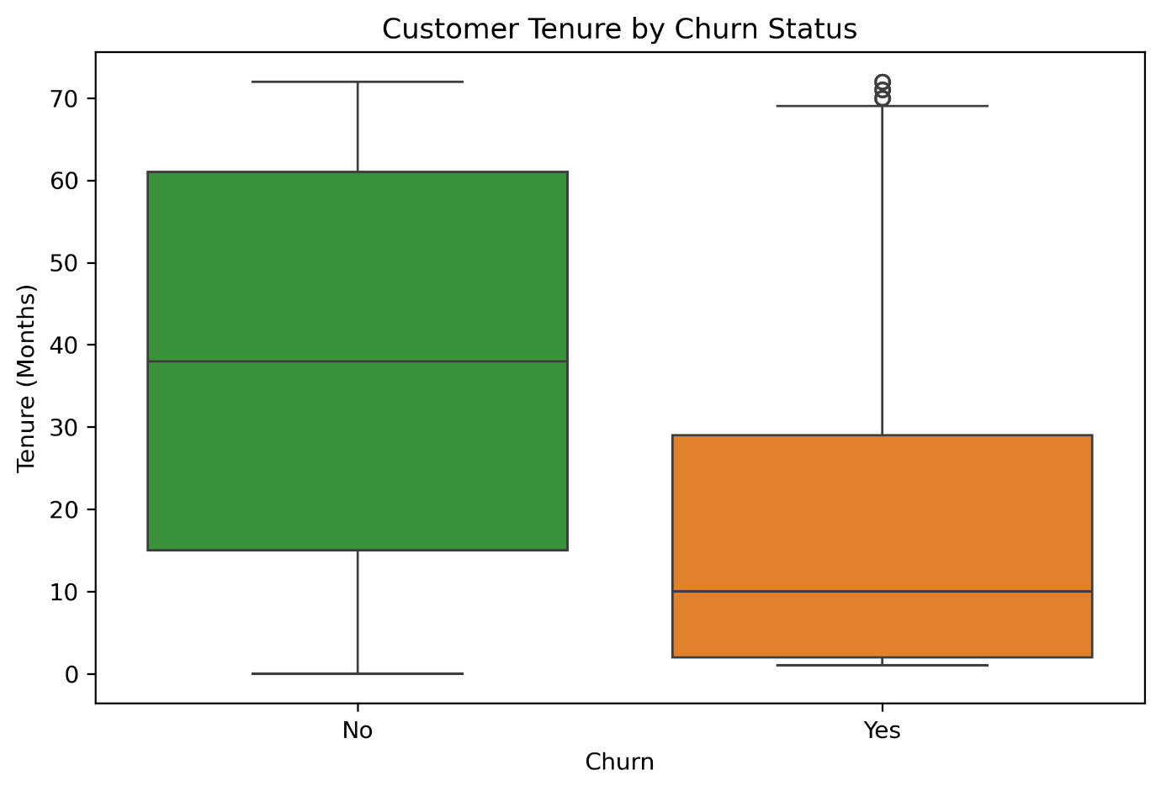Figure 1: Customer Tenure by Churn Status
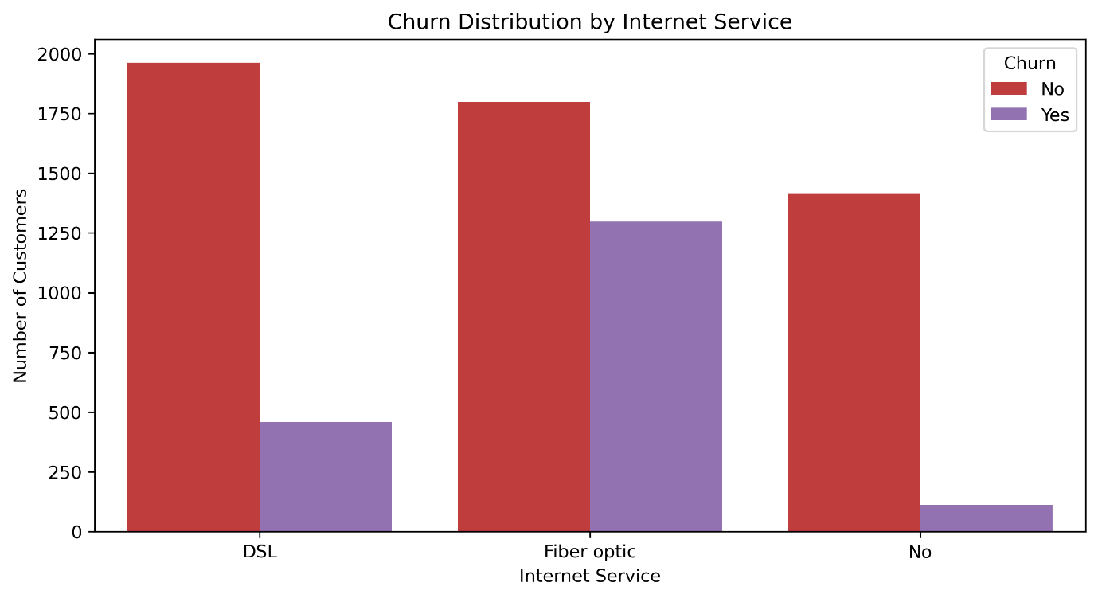Figure 2: Churn Distribution by Internet Service
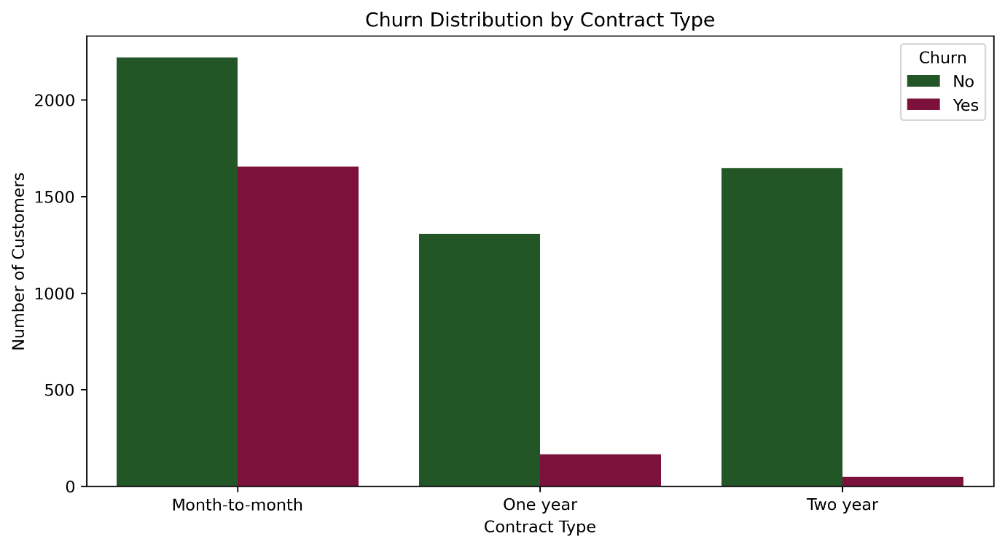Figure 3: Churn Distribution by Contract Type
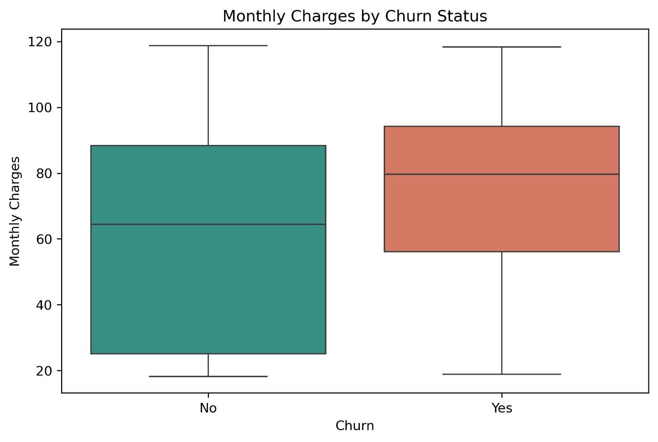Figure 4: Monthly Charges by Churn Status

Model Selection and Building
A Random Forest classifier was selected for this analysis due to its ability to handle complex relationships, robustness against overfitting, and strong performance on tabular data. The dataset was preprocessed through encoding of categorical variables and splitting into training and testing sets.
The model was trained using an 80/20 train-test split with stratification to preserve class distribution. Class imbalance was addressed using class weighting, and additional improvements were achieved through threshold tuning to enhance churn detection.

Model Evaluation
The model’s performance was evaluated using classification metrics including precision, recall, F1-score, and ROC-AUC. The model achieved an accuracy of approximately 80% and a ROC-AUC score of 0.83, indicating good predictive capability.
After adjusting the classification threshold, the model showed a significant improvement in detecting churn customers, increasing recall from 0.50 to 0.71. Although this resulted in a slight decrease in precision and overall accuracy, the model became more effective in identifying at-risk customers.
Feature importance analysis identified key predictors of churn, including tenure, monthly charges, contract type, payment method, and service-related features such as internet service and technical support.

Recommendations and Business Implications
The insights from the model can be used to develop targeted retention strategies:
- Focus on early-stage customers: Implement onboarding and engagement strategies for customers with low tenure
- Promote long-term contracts: Encourage customers to move from month-to-month to longer-term contracts
- Review pricing strategies: Address potential dissatisfaction among customers with higher monthly charges
- Enhance service experience: Improve support services such as technical support and online security
- Target high-risk segments: Use the model to proactively identify and engage customers likely to churn
Further improvements could include applying advanced techniques such as SMOTE for class balancing, experimenting with models like XGBoost, and integrating additional behavioural data to enhance predictive accuracy.

